Printing - How to print in the Weitz-Lab
The printers at the Weitz-Lab belong to the network of public printers of the Harvard SEAS community
https://www.seas.harvard.edu/service-center/printers-and-copiers
(https://www.seas.harvard.edu/computing-office/printing).
Useful link : https://harvard.service-now.com/ithelp?id=kb_article&sys_id=KB0010888#ip

Weitzlab-Printers Currently, there are two printers available to our lab:

HP LaserJet M3035 MFP
  - located between the two offices, next to the kitchenette
  - black/white printing (single sided), fax, copier, scanner (into your Harvard email mailbox)

HP Color LaserJet CP4520
  - located in the hallway, next to the chemroom
  - color printing (double sided)

Installing printers on your computer
To use these printers you have to add them manually with a network connection. This process is described below.

Do not use a USB cable to connect your computer to the printer!
Before you start adding printers , make sure that your computer is connected to the Harvard University / Harvard Secure network, through Wi-fi or an ethernet cable!
Do not use Harvard VPN (Cisco AnyConnect)!
(If you are connected to the Harvard network, you don't need to establish a VPN connection to Harvard - you are already part of the network!)
To set-up these printers you must follow the instructions of the Harvard SEAS Computing website:
How to add a SEAS printer to OS X. How to add a SEAS printer to CentOS.
How to add a SEAS printer to Windows. How to add a SEAS printer to Ubuntu
The following table contains the necessary information to set-up the two printers on your computer.
Queue | Building | Building Location | Type | Model | Hostname
mckay-5flr-clr | Gordon McKay Lab | 5th Floor Hallway | Color | HP Color LaserJet CP4525 | mckay-5flr-clr.seas.harvard.edu  or  60ox-3flr-clr2  Or  IP Address: 10.243.35.103
mckay-5flr-weitzlab | Gordon McKay Lab | 5th Floor Weitzlab next to the sofa | B&W | HP LaserJet M3035 MFP | mckay-5flr-weitzlab.seas.harvard.edu

Which driver should I use?

HP LaserJet M3035 MFP
Choose theM3035 MFP PCL 6 driver; it offers faster printing than PS (postscript).
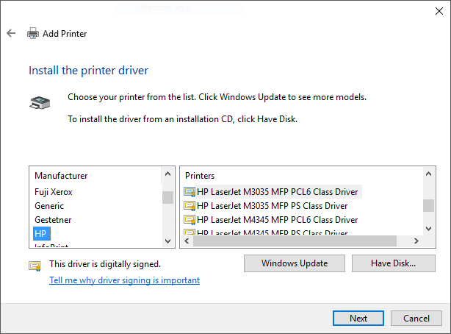

HP Color LaserJet CP4520
Choose the CP4520 series PCL6 driver.
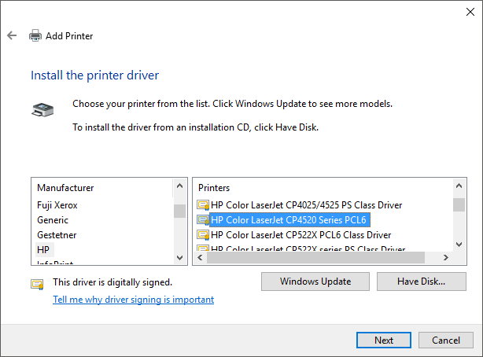
In case of problems, please contact HUIT Service Desk ithelp@harvard.edu.

